Executive Summary

**Campaign Overview:** GCON Office Furniture is a Chinese company that has expanded internationally. The company is targeting business men and women and corporations.The objectives of the campaign was to, firstly increase sales, and secondly increase awareness. This was done through strategic adwords, use of negative keywords and furniture sales promotions. The campaign ran for 21 days (29/4/17-19/5/17) that was split into three phases. **Phase One** was aimed at raising awareness of the company and its products. **Phase Two** attempted increasing the CTR and finally, **Phase Three** focused on expanding adwords. Furthermore, the campaign focused on five different segments. Modern Furniture, Purchase Workstation, Office Awareness, Office Combo and Office Furniture. Despite all of this, not all of the budget was used. The company however, **far exceeded expectations** with a CTR of 0.94% and a total of 970 clicks.

**Key Results:** The campaign saw a 17% increase in daily visits. This resulted with a higher CTR (0.94%, more total clicks (970) and a 20% increase in sales. This was promising to see as it greatly exceeded the initial goals. Furthermore it was more cost efficient and cost effective than originally thought. The average click cost $0.11 which meant that only $112 of the budget was used. Because of this the ROI was greater than planned. In total 53 searching keywords and 20 negative keywords were added.

**Conclusion:**

A key to the success of this campaign was the clever use of keywords and negative words. This, combined with good group dynamics and constant updates to the adwords meant that the was advertisment campaign was a resounding success. The group also used targeted demographics and geo-targeting to focus customers and their needs. The different goals and changes made throughout the phases of the campaign made for a more well rounded and successful advertising campaign.

**Future Online Marketing Recommendations:**

Following on from the successful campaign, recommendations have been provided to the client. They have been divided into two categories. Musts and optional

**Must do reccomendations:**

The client needs to continue to add keywords and optimise the existing adwords. This will continue to expand the amount of clicks that the company receives.

The company must also add a social media component in the future. This is not an immediate necessity but as the company grows it would be beneficial.

The company could improve their site in order for users to enjoy their browsing experience while on the site. This would also give the site a more polished look.

**Optional reccomdations:**

For the distant future and if the company increases their advertising budget, they could create youtube ads that play to a targeted audience with a focused message.

Industry Component

**Campaign Overview:**

The primary goals of the Google AdWords campaign were based on the marketing goals and aims of GCON furniture which are 1.) Generate greater sales in both revenue and volume and 2.) Raise awareness to the public. GCON Furniture is still behind in digital commerce with the aim of achieving a CTR of 0.5% calculated from 200 clicks. Campaigns were optimised in four dimensions: Ads, landing page, keywords and targeting (including schedules, locations) in order to maximising CTR, CVR and minimising CPC. keywords with high CPC or low CTR were banned after evaluation and replaced by other keywords suggested by Google Keyword Planner. The campaigns ran roughly 21 days from 29th April to 19th May on Google Search Network and Google Display Network. For the Google Display campaign, it aimed to improve site traffic and drive awareness through impression.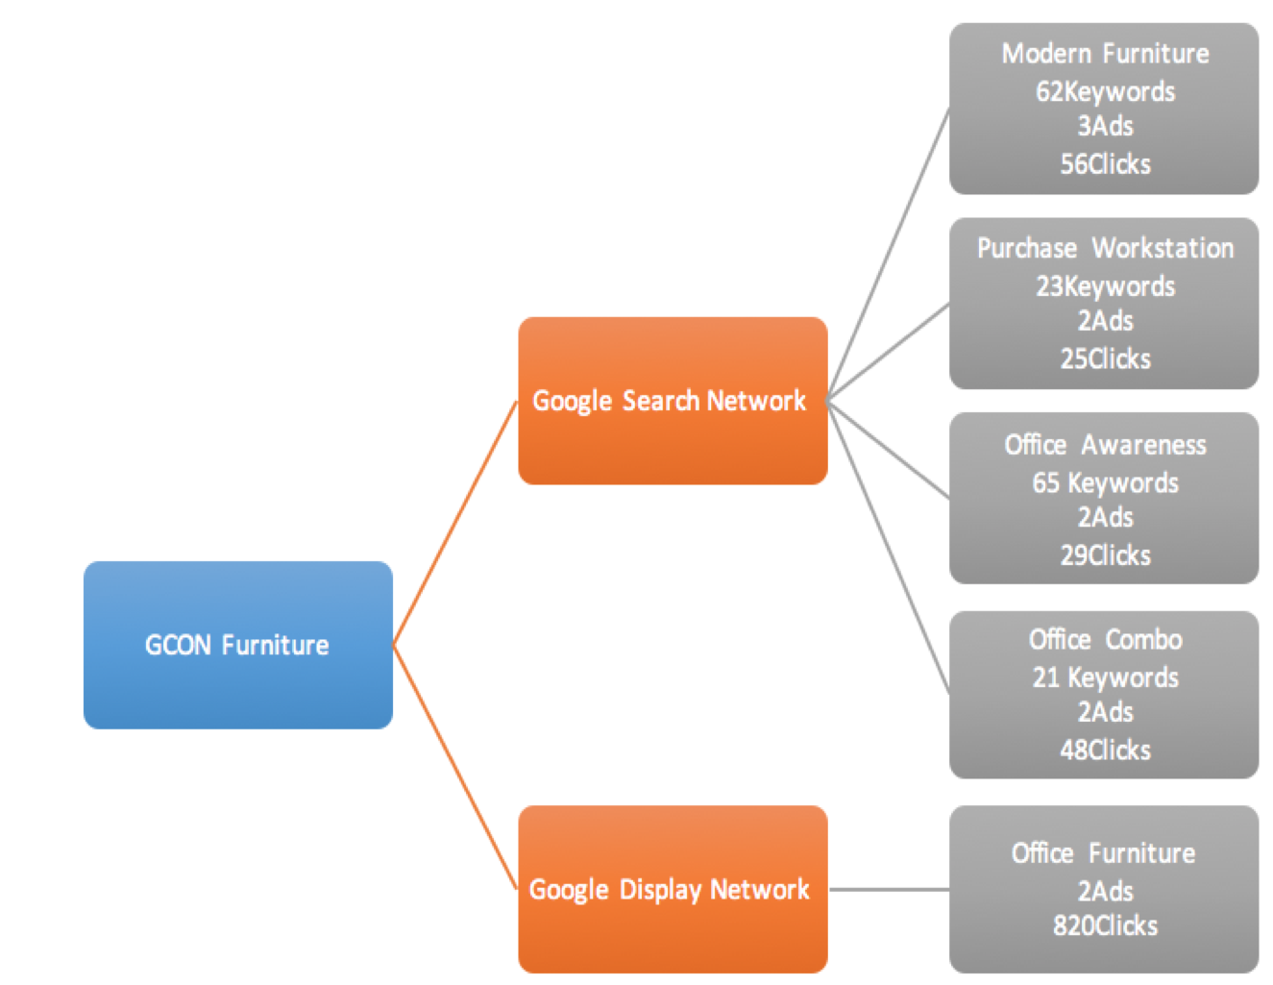

Five campaigns were created: Modern Furniture, Purchase Workstation, Office Awareness, Office Combo and Office Furniture. These campaigns directed users to the client’s website and included a total of 12 Ad Groups, 171 Keywords, 12 Ads and 978 clicks as shown.

The original $250 budget was readjusted and allocated to use 32% through week 1, 35% through week 2 and 33% through week 3. Money was allocated to search engine bidding as optimising the search engine results is crucial in increasing sales. We devoted the majority of the budget to search advertising through Google Search Network and revenue conversion techniques using Google Display Network strategy as viewed in table below.

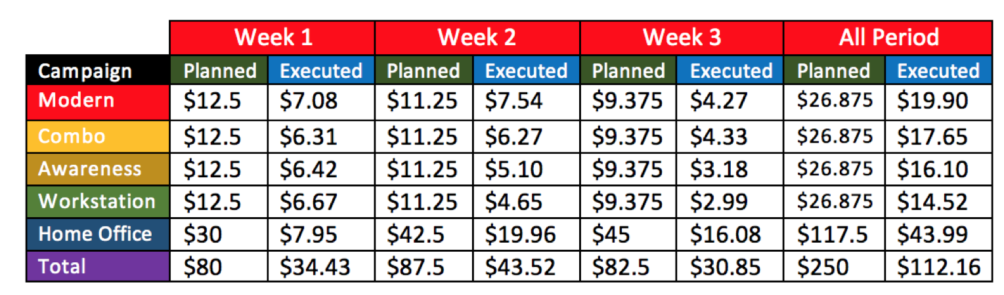

**Evolution of the campaigns strategy**

**Phase 1** (29 April – 5 May): The campaign in week 1 was used to raise awareness of GCON Furniture and to test for the keywords and reactions of different ad groups. Due to the low reputation of GCON Furniture, we focused on the relevance of the search results. Much effort was put into raising the impression and CTR. The metrics and effectiveness of the results was marked every day and our team discussed solutions to improve after three days. We added mobile bid adjustment into all campaigns (100% for mobile and tablets, and 50% for computer) which is to increase the traffic on mobile and tablets and limit those on computers. The reason behind is that nowadays, people usually browse more with their mobile rather than with computers . It is more effective to put the resources on mobile search in order to raise impression and CTR. Although it is inconvenient for them when they go into the website, they will search again with computer if they are interested to purchase. The average position of our campaigns were also under consideration. We implemented the suggestions from Google AdWords which a total of 53 searching keywords and 20 negative keywords were added to the four campaigns. This action helped to maintain the Ad positions at the level of 2 to 3.

**Phase 2** (6 May – 12 May): The performance seemed unsatisfactory in the week before, the average CPC was much higher than we expected and the number of clicks was under expectation. Therefore, the bidding strategy was changed from maximize clicks to manual CPC in order to better utilize our budget. As the consumption rate of furniture is quite low, the expected CTR is set at 0.5% only. Keywords with CTR lower than 0.3% (47 keywords) is paused according to the recommendations of Google Keyword Planner. Furthermore, we have found that the reactions of Display Network were greater than Search Network in terms of both clicks and CTR. To counter this, there was a slightly budget adjustment. Each Search Network budget was decreased to $1.25 and the Display Network have $5 more. The result of the changes is significant. The average CPC fell half from $0.22 to $0.10 and the number of clicks increased 163.5%. A new video ad was uploaded on different social platform as required by the company. It is used to promote the discount bundles and sales in upcoming days. This influenced the performance of an Ad Group “Office Combo”. The impressions and clicks have constantly raised in the following week.

**Phase** 3 (13 May – 29 May): We started the week by increasing the budget used on the campaigns since there was still a large amount of budget left after the first two weeks. It is quite surprise to see this situation. We added 3 more Ad groups immediately which aimed to catch up with the original budget and enhance the overall performance. However, it was carried out too late and the effect was insignificant. Despite the increase of impressions, the number of clicks had a 6.4% decrease compared to week 2. We belief that is due to the end of the sales promotion. The short video ad was taken off and effected the performance of the campaigns. Apart from introducing new Ad groups, the radiuses of the campaign target locations were enhanced to 300 km around Brisbane in order to achieve to a wider market. Although this may not affect much with the sales, widening the promotional areas could build up the company’s reputation which is also one of the aims of the campaigns. The overall results of the ad groups were satisfactory especially the increasing conversion rate along the three weeks and the improvement of CTR.

**Key Result**

With the constant management of our campaigns, we performed above expectation of our website visits. General GCON Furniture inquiries increased by 34%, with the sales increased by 20%, which exceeded our primary marketing goals of generating greater sales in both revenue and volume. The AdWords campaign have generated a total of 970 clicks at an average of $0.11 each with an overall CTR of 0.94%, which exceeded our expectation in every key metric and successfully met our goals of raising awareness to the public with further information below.

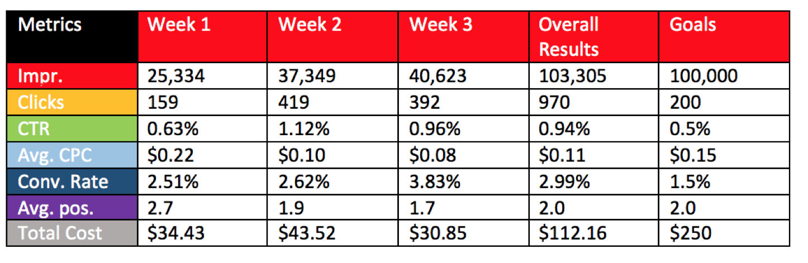

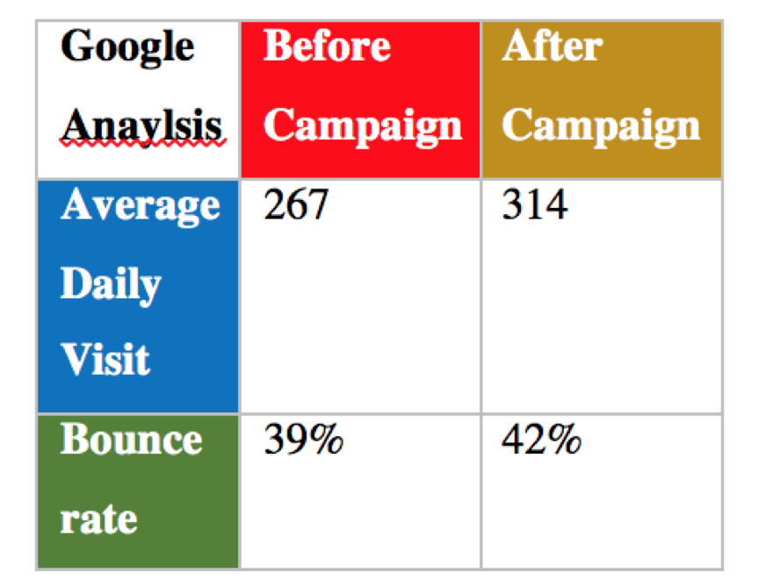

Google Analysis was used to monitor the website traffic of GCON Furniture, the result was surprisingly good with a significant growth of website visitors and bounce rate. The number of average daily visitors increased from 267 to 314. The bounce rate increased, which reflected the delivered quality traffic of the campaign was accurate with the targeted keywords.

Relevant keywords were critical to the campaign’s success. We discovered that broad match keywords such as online purchase, order online, and keywords for specific products such as small white office desk and corner desk with hutch were less effective. In order to maximise the effectiveness of the ads, structured snippet ad extensions and sitelinks were added to all campaigns for further improvement and optimisation.

**Conclusion**: The AdWords campaign was performed far exceeded the established goals of total number of clicks by 970 and CTR by 0.94%. These results definitely created a significant impact to the website visits and sales improvement. In this three week period, number of visitors in GCON Furniture websites significantly increased. It proved that Google Adwords played a role of accomplished the goals of GCON Furniture, all of this can be attributed to dedicated teamwork, proper account management and excellent communication with GCON Furniture.

**Future Recommendations**

Firstly, a recommendation would be to use all of the provided money in the budget. This would allow a more efficient and optimal campaign that can reach more people and increase sales. It would also be suggested to fully utilise geo-tracking as this could focus the campaign greatly.

In addition to this, display ads could be utilised to a wider degree, this would greatly improve the views that the site would get.

Furthermore it is suggested that the company targets back to work periods of the year in order to capitalise on the increased need of office furniture during those periods.

All these recommendations in conjunction with the ones created in the executive summary will aim to increase the ROI and CTR.

**Learning Component**

**Learning Objectives and Outcomes:**

First of all, we are appreciative of Google Online Marketing Challenge(GOMC) for providing us with an excellent opportunity which is very valuable during our student life. Since most courses are worked in personal or in group. GOMC is not only educational learning process, but also a practical session which interact with a real market world. Through this time of challenge our team aim to learn useful skills about online marketing. There are two main skills during this challenge, first is negotiate with real company. We need to find actual company as our client by ourselves, and need to communicate with them in time to gather information to develop our strategy and market plan. During data gathering process, we learned how to use Google Analytics to collect company’s data, such as company website’s DV(Daily View), Return Visitors, Google Search etc. which help on data collection which show company’s situation. On the other hand, we keep in touch with company’s manger frequently to make sure every data is valid and correct. And this is not only tests our skills on data collect, but also test our responsibility because of we need to responsible for our client, we must make sure every detail of our advertising is a hundred percent true without any false information and create as much benefit as possible to our client.

Another skills is to create an advertising video. How to make an efficient and attractive online advertising video is what we want to learn during this challenge. Because nowadays people are more rely on internet rather than newspaper. Thus companies are more likely to enlarge their brand awareness online. Due to GCON’s head company is located in China and they only entered Australia a few years ago, their brand awareness not strong enough in Brisbane. We need to focus on their products’ feature and show people what are strength of products and how differ with other brands. Besides content of video, we also need to learn how to use a video edit software. We use Adobe Premiere Pro CC as our edit tool. Adobe Pro is one of professional editing tool on video editing and creation and it is a necessary skills in advertising in future career.

Reviewing all processes we have done during this Google Online Marketing Challenge, it is a good opportunity in training our group work ability like working with others, and to cooperate with groupmates. Furthermore, we also learn some negotiation skills with clients to know their needs and wants to maximize the benefit. Last but not the least, besides these work skills, technical skills like video editing and data collecting are both important experience during Google Online Marketing Challenge.

**Group Dynamics:** As we know, GOMC is an academic and challenging project that requires adequate academic knowledge and comprehensive arrangements to implement. When we worked as a team in planning a campaign for the specific company, our time coordination, organizational skills and resilience were tested. During this processes, we noticed that the busy schedules might be most challenging obstacle the project. Meanwhile, our members gave the distributions of the tasks separately which means we needed to combine all the contributions and make it reasonable and smooth. Because our target client is a Chinese furniture company, our biggest advantage is that we are a mixed team which has Chinese members to build a good communication relationship with our client. our team also has local member to explore the local market situation that makes progress on the tasks. For communication and coordination, Google Drive, Docs, Calendar, Sheets, Hangouts and Gmail were utilized to ensure that we maximize the communication and sharing documents. Google Drive and Docs are the most frequently used tools which allowed us sharing and combining our tasks even we were far distance away from each other. Google Sheet was used to help us to control our budgets strictly in the process of planning campaign to ensure that we are efficient and cost-effective to complete our project. In addition, Google Analysis was used to monitor the website traffic of GCON Furniture. For our target client, we utilised Gmail tool to contact GCON Furniture for their permission of doing this campaign and communicate with them for gathering information to develop our strategy and marketing plan. Following that, we built a good relationship with our client and created an effective plan for their business advertising.

**Client Dynamics:** During process of company decision, all of group members unanimously agreed with cooperate with GCON, and GCON agree to be our client. The biggest challenge for us was: Since GCON head company was established in China, and open subsidiary corporation later in Brisbane, Australia in 2010. Which means there was not much information about GCON exist in local website. Thus it was hard to find data like PV(page view) of their website. We tried to find data from Google Analytic at beginning, however there not much data could be used. After several times of attempts, we decided to find out data from GCON website in China. Finally we found out some useful data such as daily visitors and how viewers distribute in other Chinese formal website.

**Future recommendations:**   
Campaign strategy: With the expansion and development of digital commerce, the e-commerce system should be built and skillfully applied in future consumer services.

Learning experience: In the future campaign plan, we would take the initiative to learn more about Google Analytics on data analysis and video editing tool software such as Adobe Pro video editing and creation to improve our advertising skills.

Group dynamics: We would arrange our schedule reasonably and need all the members have the agreement of our decisions and actively complete the allocated tasks.

Client dynamics: We would contact with the potential client as early as possible to ensure we have enough time to gather the company information before we start the campaign.